CMP306 part 1

Functional requirements
- All asset information should be stored in a database.
- The database should be future proof to allow it to be used in other systems.
- All standard CRUD commands should be able to interact with the database.
- New hardware should automatically be collected before being added to the database.
- The database should only hold suitable information on assets ie hardware info and location data.
- The database should tell the users where the hardware is being stored when searched for.
- An additional column should be added to the database to add extra notes.
Non- Functional requirements
- The system should take no longer to teach than teach than 30 minutes.
- The system should be reliable.
- No delays to data entries due to screen refresh rate.
- The system should function in an windows 10 environment.
- The system must be a desktop application not a webpage service.

Use cases

Login to program
Goal level (Sea level) Blue
Actors
User – company employee data entry , IT maintenance, company security
User - Company employee database
System – the to be developed software
Main Success Scenario
- The company Employee enters their company ID and password.
- The system searches the company’s employee database using their entered information.
- When the system finds the employees information in the database. A result is sent back from the database to the system.
- The system uses the result to allow the employee access to the whole system.

3 A Invalid login info
- The system cannot find the employees info in the database.
- No result is sent back by the database to the system
- The system displays a error message and stays on the login page.

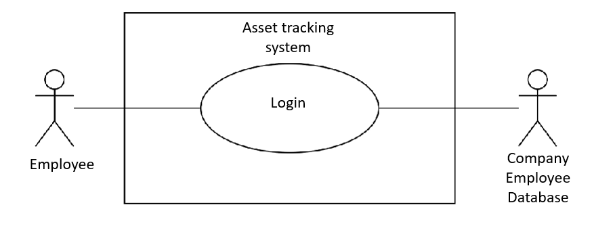

Add Asset
Goal level (Sea level) Blue
Actors
User – company employee data entry
User - Company Asset database
System – the to be developed software
Main Success Scenario
- The employee presses the add asset button.
- The system gets the hardware info it can get and partially fill out the forms.
- The employee enters any remaining hardware information.
- The employee enters the Id of the building the asset will be used or stored in.
- The employee enters any specific location data if any and then press the submit button.
- The system takes all information and sends it to the asset database to be entered.

6 A. Invalid info entered
- The system validates that the entered information is the correct type of info to be entered and continues.
- The system validates that the vital needed information has been entered and continues.
- If the entered information passes steps 1 and 2 the system will send the data to the database. If not, an error message will pop up saying way the action cannot be made.
3 A. adding aborted halfway through.
- The user clicks the cancel button.
- The system will delete any stored information and open the home page.

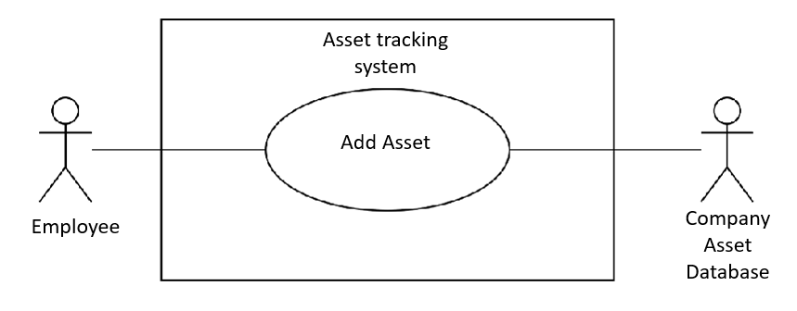

Class Diagram 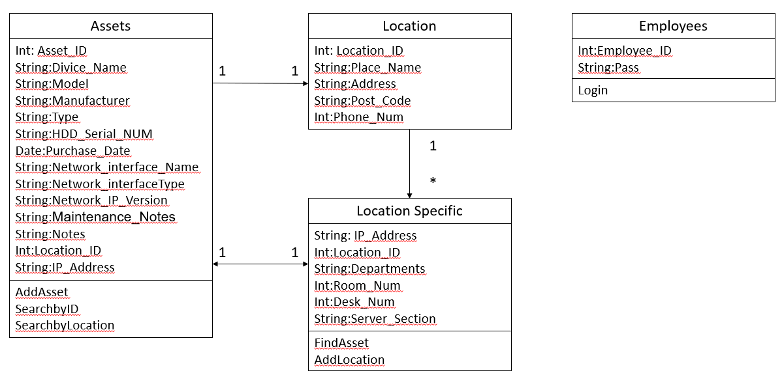
Methodology Justification
For my project the methodology I have chosen is the evolutionary prototype. The evolutionary prototype is a mix of the prototype methodology and the incremental Methodology. Whereas most prototypes are thrown away after an iteration is designed an evolutionary prototype is made initially and kept. Then on every new iteration is added on top to the existing prototype. The main benefit of the evolutionary prototype is the ability to start the project by focusing on the most understood requirements. Then by presenting them to the client the developer can quickly determent if this is actually what the client requires or if an new prototype is needed. One there is a prototype the client is generally happy with. Iterations can begin.

Another benefit of this approach is that each version of the prototype could be released to the client to user test if the prototype is functional enough. Just like the incremental methodology this is where the two methodologies mix and gain better benefits. In summery the Evolutionary prototype starts by finding a basic prototype that the Client is happy with and the using Incremental methodology to develop the protype to a fully realised system.

I have applied this Methodology to my project due to the small time frame for completion and as the project is relatively small, I will be clear witch iteration contains which functionality. Since, as said, the project is comparatively small (one program vs a system) I have decided that every new function such as adding an asset of logging in will be its own iteration. By adding this I has made I clear how long each iteration should take based of its complexity i.e., designing a webform takes longer that writing a function. With this I can tell if I am still on track with the deadline of if I must increase the worktime during the week. In the first 4 iterations I created the backend database, the frontend of the windows form, connected the database and created a login as well as adding to the database. The main tool I used to keep track of the iterations was to use git hub. And for every new iteration I made a new branch and merged it back into the main once the to function was sufficiently tested. Another useful tool that I have utilised was git hub’s project boards. A form of Kanban board. By using this tool, it made clear what tasks were left to complete and which were complete. I didn’t move a note until the corresponding testing had been completed and passed. This has also given me an in site in to roughly how many iterations are left before the completed program can be submitted. Given that every note is its own iteration or set of functions.

By developing a prototype that the client and myself are happy with I have only had to design the user interface once and make minimal changes to it instead of doing a complete redesign ever iteration. It is also has been of benefit to the client since they know what the final edition will generally look like and know wat the current version of the prototype can do functionality wise. Finally, of course by adopting this methodology I have prepared myself for and unforeseen changes to the requirements and can go back to an earlier iteration to make changes if need be.

Kanban Screen shot 01/11/2022
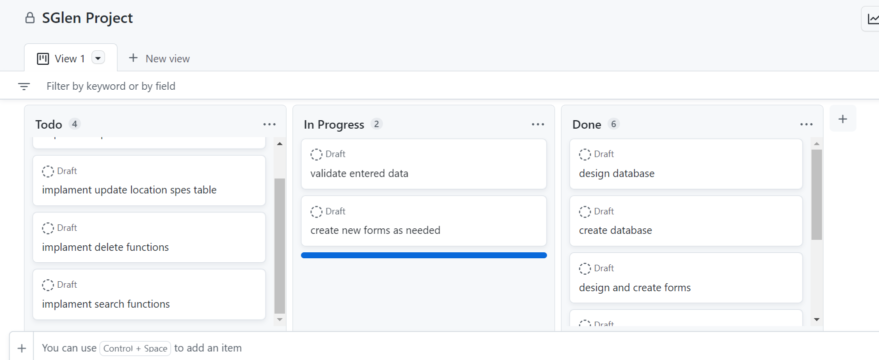

Prototype passwords
1 Pass
2 Admin (the one I use in my demo video)

Github link
https://github.com/cmp307/project-nnja6lade.git

